St Andrew’s Church Little Snoring

Flower Festival

Friday 14th to Sunday 16th July 2017

11 am to 4 pm

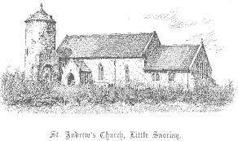

Norfolk Life

Programme 50p

Welcome to the 2017 St Andrew’s Church, Little Snoring, Flower Festival. The Festival takes as its theme NORFOLK LIFE to celebrate the beauty and diversity of our lovely county. We hope you enjoy our arrangements, explore our crafts and take tea with us.
Thank you for your support in helping us to maintain this beautiful, historic church.

1. Norfolk Lavender Arranger: Michelle Driver
2. Norfolk Cricket Week Arranger: Pam Thomas
3. Fakenham Races Arranger: Janet Harvey
4. Pensthorpe Natural Park Arranger: Veronica Ross
5-6. Stately Homes Arranger: Anne Colchester
7. Sandringham Flower Show Arranger: Gill Davies
8. Norwich City Football Club Arranger: Sue Hayes
9. Norfolk Bird Life Arranger: Mandy Price
10. This Farming Life Arranger: Cara Ross
11. Beach Huts Arrangers: Joanna and Gwendolen Otte
12. Windmills Arranger: Sheila Riddell
13. Lighthouses Arranger: Linda Wash
14. Cromer Crabs Arranger: Bridget Mann
15. Norfolk Microbreweries Arranger: Gill Davies
16. Seals at Blakeney Arranger: Rebecca Hutchison
17. Lifeboats Arranger: Caroline Palmer
Display boards in the chancel are by the children of
Little Snoring Primary School
Tel: 01328 878362
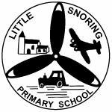
and
Little Snoring Pre-School
Tel: 07733144666

We wish to thank all the businesses and individuals who donated raffle prizes, cakes, plants, made scarecrows etc.
as well as all the flower arrangers, stewards and everyone involved in the organisation of this event.

A special mention to the following contributors:

Walsingham Farms Shop – Abbey Gardens, Walsingham – Bert Frew, Walsingham – Black Lion Hotel Walsingham – McAully Flying Group – Thursford Collection –
The Green Man Public House, Little Snoring –
Aldiss Department Store – Hillside Animal Sanctuary – Pensthorpe Natural Park – Fakenham Garden Centre – Owl Tea Rooms, Holt – the passion of flowers, Holt – Tesco – Morrisons – Aldi – Little Snoring Primary School – Little Snoring Parish Council.

