NORFOLK COUNTY COUNCIL proposes to make a Temporary Traffic Order affecting the U14069 Thursford Road from a point 90m north of its junction with U11414 The Pastures heading north for 90m in the PARISH OF LITTLE SNORING because of new water supply.

The road will be temporarily closed (except for access) from 15th August 2017 to 17th August 2017 for the duration of the works, expected to be about 3 days within the period.

Alternative route is via: U14069 Thursford Road, U14006 The Hill, C317 The Street.

(If necessary the restriction could run for a maximum period of 18 months from the date of the Order).

Penalty: £1000 maximum fine on conviction and/or endorsement for contravention.

In the event of the start date being delayed the new start date will be displayed on site in advance.

The person dealing with enquiries at Norfolk County Council is Martin Dixon (Community and Environmental Services) Telephone 0344 800 8020.

Dated this 28th day of July 2017

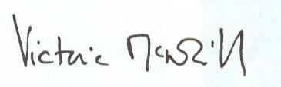

Victoria McNeill
Chief Legal Officer

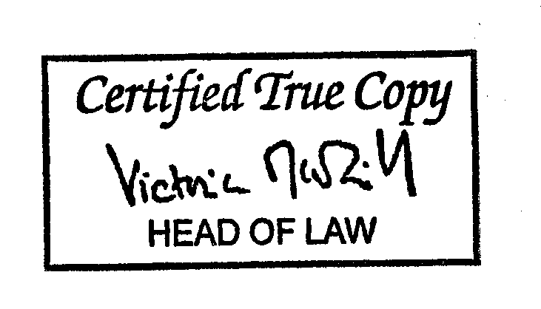

County Hall
Martineau Lane
Norwich
NR1 2DH

