Newsletter
Nov / Dec 2019
If you would like to include an article for publication in the Newsletter,
please send your piece to the Editor at littlesnoringpc@googlemail.com
Minutes of meetings and information about the Parish Council are available to view on the village website: http://littlesnoringparishcouncil.norfolkparishes.gov.uk/

Little Snoring Parish Council

Contact details
Clerk /editor
Joanna Otte
01328 822366

Councillors
(unpaid volunteers)
Jetta Buck
01328 878076

Stephen Harvey
01328 878257

Margaret Kennedy Chair
01328 822157

Simon Price
07971 502834

Catherine Redford

Liz Spanton
01328 878144

Andrew Talbot Vice-chair
07818 507255

Fakenham Parish Church holds its
Christmas Tree Festival
Thurs 28 November to Thurs 5 December
between 10am and 8pm daily (between 12.00noon and 8.00pm Sunday 2nd).
Entrance to the Festival is free, but please bring a bag of coins to place at the charity trees of your choice. There will be a Christmas Bazaar selling a wide range of Christmas goods; refreshments, a Tombola and a Grand Draw. Prayers will be said hourly for the charities and there will be six Prayer Trees where you can write a prayer of your own.

There is disabled access throughout the Church and both toilet provision and a baby changing unit. All ages are welcome to this family occasion. Coach parties need to book in with the Festival Office.
To find out more about the Festival telephone 07999 532002 or log on to the Festival website:
www.fakenhamparishchurch.org.uk

Little Snoring Parish Council
Little Manor, Thursford Road
Little Snoring, NR21 0JN
Tel: 01328 822366
littlesnoringpc@googlemail.com

Members of the public are invited to attend the Parish Council meetings.

The next meeting is on 11 November
at 7.30 pm in the Community Room on the Playing Field.

Arts and Crafts in the Community Room, Little Snoring
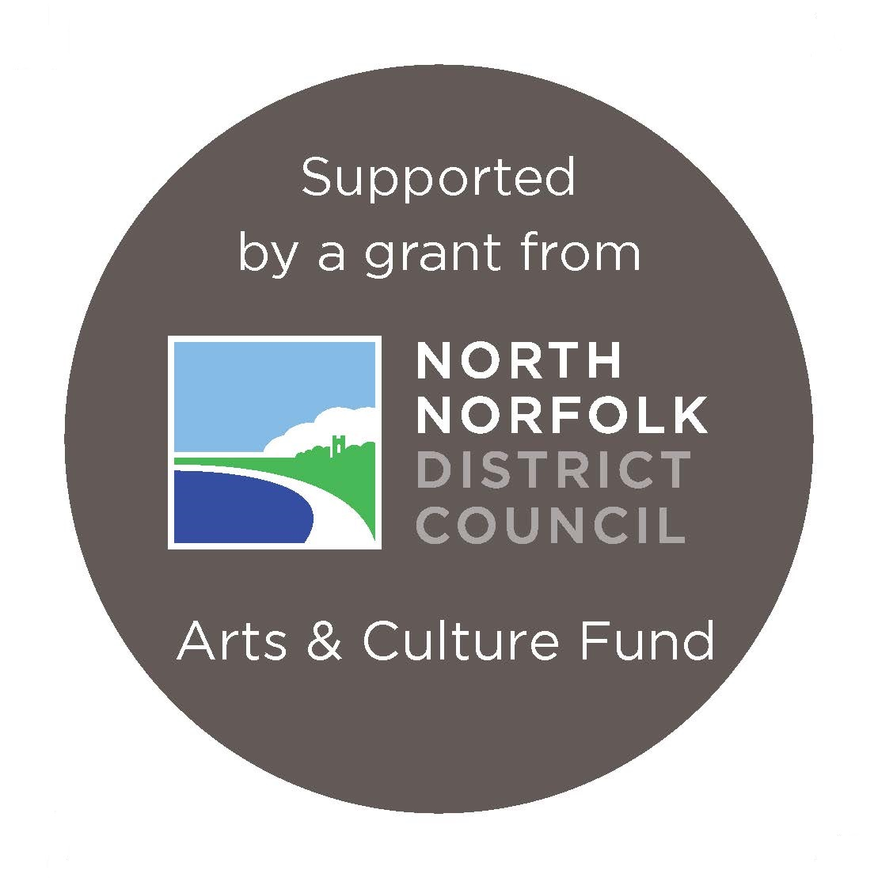
Photography
Is anyone interested in photography and the formation of a Little Snoring Photography Group? This would be a friendly group with all levels of experience, so that we can help and encourage each other. No need to have an expensive camera, just an interest in photography and improving your pictures.

The aim would be to hold monthly meetings and arrange some outside speakers, and if there is interest, to organise some training days. Once the group is going we can discuss and identify what type or training would benefit the members. This could range from basic “getting off auto” to more advanced such as landscapes or wildlife.

We would meet in the Community Room, and look to start in the new year. I will contact those interested in December.

If you are interested then please email Andy Talbot at andrewtalbot@sky.com

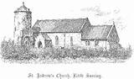
Village Grants
Grants are available to residents and groups of the parish of Little Snoring to pay for specific items. Applicants need to be able to demonstrate that they are in need, hardship or distress.

The Trustees of Little Snoring Charity are happy to consider requests from anyone in need. For more information and an application form, please contact the Clerk on 01328 822366 or email littlesnoringcharity@googlemail.com

Little Snoring Pre-School for 2 – 4 year olds. Funding is available for 3 & 4 year olds and eligible 2 year olds. Contact Mandy on
07733144466 / 01328 878657; email littlesnoringpreschool@gmail.com; or message us through Facebook: https://www.facebook.com/Little-Snoring-Pre-school-418085078336515/.
We look forward to hearing from you.

CUPPA IN THE COMMUNITY
Monthly afternoon tea and cake (and a raffle)
in the Community Room run and organised by volunteers
at 2.00 pm on the third Monday of each month –
18 November and 16 December 2019.
If you can come, please contact Margaret 01328 822157 as
spaces are limited and you will need to book a place.
For only £2.00 you can have tea or coffee and cake.
We may be able to help with transport if needed.
Do bring along a cake to share or something for the raffle.
The money that we raise at the Cuppa in the Community usually goes towards paying off the cost of the kitchen cabinets and sinks which were generously installed at no cost by Les Mitchell. The total cost of the kitchen cabinets and sinks was £1,784. So far we paid off almost £800.

Occasionally the Cuppa in the Community donates the day’s funds to a charity e.g. in November 2018: £100 was donated to the Poppy Appeal; in December 2018: £150 to First Focus in Fakenham; and in June 2019: £70 to Action for Children.
The Macmillan Coffee Morning in September 2019 raised £300.
Thank you for your support.


St Andrew’s Church
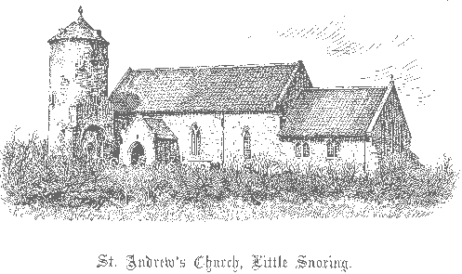
Church Services
10 November 12.30 pm Short Service of Remembrance
at War Memorial and Wreath Laying.
22 December 11am Carol Service
29 December 10.30 am Group Eucharist.
Treat yourself to a new read today or choose Christmas gifts at The Book People Big Book Boost and support Little Snoring Pre-School at the same time.
- Go the to www.thebookpeople.co.uk/bigbookboost
- Make an online purchase over £10
- Select Little Snoring Pre-School at the checkout
- The Book People will do the rest Thank you for your support

Snoring Knitters
The group of around 10 ladies from both The Snorings meet on the last Tuesday afternoon in the month. They are still very busy continuing to knit, crochet and sew for charity. Amongst the variety of items made one lady is ingeniously creating twiddle blankets from recycled items, from old curtains to an unwanted jacket, nothing goes to waste.
We bring our work with us, discuss projects and have a cup of tea and
indulge in the odd biscuit or two!!
If you enjoy knitting, crocheting or sewing do come and join us on between 2pm & 4pm at the Social Club, Great Snoring on the last Tuesday in the month
Contact Frances on 01328 878967 for details.

in aid of St Andrew’s Church
in the
Community Room on the Playing Field
on
Wednesday 5 December 10 am – 12 noon
Refreshments, cakes, and Raffle
All welcome
Contact Janet Harvey on 878740

The Parish Council website: www.norfolkrcc.org.uk/wiki/index.php?title=Little_Snoring_Parish_Council
St Andrew’s Church Coffee Morning

Mince Pies, Refreshments and Raffle
Wednesday 4 December 10 am – 12 noon
In the Community Room on the Playing Field
All Welcome

