Little Snoring Parish Council
Little Manor, Thursford Road, Little Snoring, NR21 0JN
littlesnoringpc@googlemail.com Tel: 01328 822366

The next Parish Council meeting is on Monday 8 March at 7.30 pm via Zoom. The link to the meeting will be available on the website.

Dates of meetings, agenda, minutes and more information can be found on the village website: http://littlesnoringparishcouncil.norfolkparishes.gov.uk/

Parish Councillors (unpaid volunteers)
Jetta Buck: 01328 878076
Stephen Harvey: 01328 878257
Margaret Kennedy (Chair): 01328 822157
Simon Price: 07971 502834
Catherine Redford: 07824 774978
Liz Spanton: 01328 878144
Andrew Talbot: 07818 507255

Little Snoring Village Activities
Once lockdown is over and we are all safe and well, we would like to organise some activities for villagers to get together and perhaps leant a new skill or brush up on an old one. So far, the following activities have been suggested: Basket weaving, Flower arranging, Drawing classes, How to use your sewing machine, Tie dyeing, Photography, Rag rug making, Decoupage, Wreath making.
Do you have any suggestions for an activity or are you interested in attending a class? Please contact Margaret 01328 822157.

The Cuppa in the Community will resume once we are back to normal and it’s safe to do so.

Lt Snoring Good Neighbours: 0333 335 5242.
Do call the Good Neighbours if you need help for example to collect prescriptions, assistance with shopping or need someone to talk to.
The telephone number is a charged at local rate

Newsletter

February 2021
To include an article in the Newsletter, please send it to the Editor at littlesnoringpc@googlemail.com

Spring is Coming
Cheer up the village
by putting an Easter decoration where everyone can see it.
- Make an Easter wreath out of flowers, willow, salt dough or paper
- Colour in a picture to put in your window
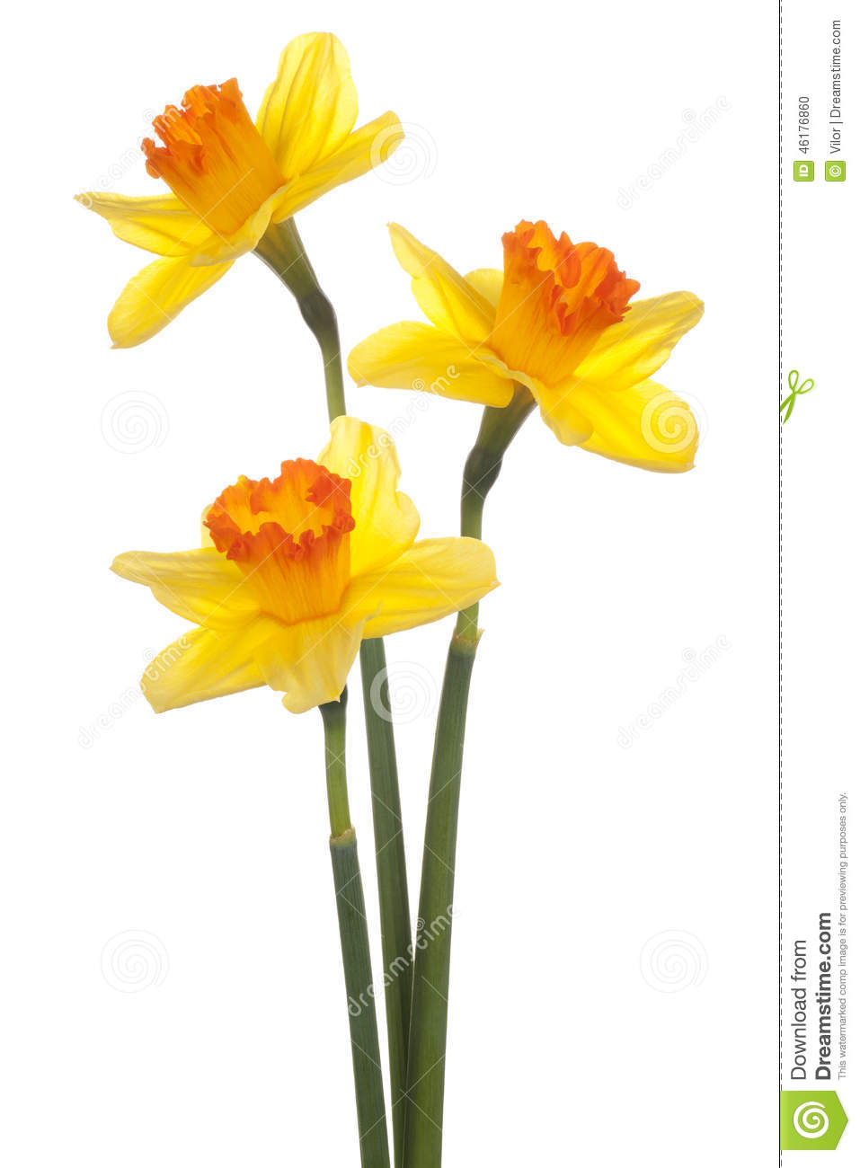
- Paint some stones
- Make an Easter chick or bunny
- Make potato or lino prints of Easter eggs
- Make a rainbow

PHOTO COMPETITON
Phone or Camera - Do you take Photos?

‘Spring in Snoring’

- Take a photo on the subject of Spring: landscape, animal, plant etc. the choice is yours.
- Photo to be taken in 2021 and within 5 miles of Little Snoring.
- Images to be jpg and max 20 MB
- Email photos to: littlesnoringpc@googlemail.com
- Closing date: 30th April 2021
- Please include your name, contact details and age if under 18.
The entries will be anonymised by the Clerk and will be judged by a panel of Parish Councillors with assistance from the County Councillor.
PRIZES will be awarded to the winners in the following age categories: under 11, 12-18 years; adults.
Prizes are sponsored by Little Snoring Parish Council and a grant from North Norfolk District Council Arts Fund supporting arts and crafts in the community.
PLEASE remember to clear up after your dog!

PLEASE remember to take you litter home
Thank you to the dedicated volunteers who carry out regular litter picks around the village – it would be great if they did not have to do this but that they do is very much appreciated.

Walsingham Way
Norfolk’s pilgrimage route

You may have seen new wooden signposts in the village. These are part of the Walsingham Way which is 37 miles of walks through beautiful, unspoilt countryside following a pilgrim route from the Medieval City of Norwich to the shrine at Walsingham.
More information can be found on the website: http://walsinghamway.co.uk/

Little Snoring Charity (for those in need, hardship or distress). Grants are available for residents and groups in the village to pay for specific items. For an application form, please contact the Clerk on 01328 822366 or email littlesnoringcharity@googlemail.com.

Covid-19 help and support:

Norfolk County Council: 0344 800 8020; https://www.norfolk.gov.uk/what-we-do-and-how-we-work/campaigns/winter-covid-support-scheme

Mid Norfolk Foodbank might also be able to help (you need a referral) 07542 106107; https://midnorfolk.foodbank.org.uk/

REGISTER FOR A POSTAL VOTE

On Thursday 6 May 2021 elections are due to take place in North Norfolk with electors voting in the Norfolk County Council elections, the Norfolk Police and Crime Commissioner Election and several Parish Council by-elections. Given the ongoing situation with the Covid-19 pandemic we want to give electors as much time as possible to change voting arrangements if voting in a Polling Station during the pandemic is not desired.

If you wish to vote by post contact North Norfolk District Council by email at postalvotes@north-norfolk.gov.uk or by phone on 01263 516046 and a form will be sent to you.

If you need to register to vote the easiest way to do so is online at www.gov.uk/register-to-vote. You can also contact North Norfolk District Council by phone on 01263 516046.

Census 21 March 2021

The Census is online (help is available if you are unable to go online telephone 01329 444972). Please do make sure you take part (it is against the law not to) and it also helps inform decisions about the things that matter to you and your community.
Visit www.census.gov.uk to find out more.

BLOOD DONATION
We need you to keep donating blood, platelets, and plasma during the pandemic. Donor centres, e.g. in Fakenham, are still open despite coronavirus restrictions. Call 0300 123 23 23 to book
To make donating as safe as possible for everyone we have made a few changes at our centres.
Read coronavirus health rules for donors (https://www.blood.co.uk/news-and-campaigns/news-and-statements/coronavirus-covid-19-updates/ )
Travelling to donate – donation is allowed despite coronavirus restrictions.
Keep your appointment and arrive on time – please reschedule it if you can't come by calling us on 0300 123 23 23
Wear a fabric face covering – this must cover your mouth and nose.

